**Estate-Link Web Application Development Contract**

**Executive Summary**

At **AdoreTz** we believe in standing out. We stand out as software development company by insisting on pushing the boundaries of Software Development, and by delivering work of the highest quality on-time and on-budget.

In this document you'll find details regarding the functionality of Estate-Link Application, our software development process, and detailed project pricing.

To make things simpler, this proposal doubles as an executable contract. We've included all necessary terms of agreement at the end, and your signature turns it into a binding project, allowing us to move forward with commencement of project immediately.

**Problem**

As a growing business being stuck in at the old way approach of selling , unable to find the connection between customer online. Inconsistency is results as many businesses struggle to reach and connect with customers on remote areas due to this approach, as well as inefficiencies, lower productivity, and increased labor costs.

**Solution**

In this Digital world it doesn’t matter which industry you belong to, every business must become digital. Have notable online presence. Become engaged with the customer in all facets of the digital world Provide easier way to interact with customer

**Objectives**

With this project ,We intent to achieve the following:

* Develop and Deploy Estate-Link by March of 2021
* Ensure the effectiveness, efficiency and security of the system as it becomes operational

**Benefits**

* Provide online presence for Estate Link properties
* Automate the process of locating properties and previewing
* Improve efficiency in business management
* Increase Customer reach

# The Estate Link Application Website

This is the developed vision that will greatly improve the overall branding, expand digital marketing efforts, and increase the Efficiency of our client establishment.

the website will include the following **pages**:

* Home,
* About,
* Contacts, Login, and Registration
* Administration
* Client page

There are a **few key features** that we'll build into the web application, which we feel are important given our clients needs:

* Preview Estate Link properties
* Blog
* Selling and Purchasing properties
* Handle inquiries

Our team is proficient in Web application development using Asp.Net core which is the best web application development frame work offering tons of impressive features such as security, speed, scalability and proficient. To ensure consistent reliability and scalability, we'll host the web application on Azure cloud.

**Our development process**

We take structured approach to Software development, our development process is delivered on-time and on-budget. Once development process kicks off, here’s what to expect:

1. Initial planning
2. Wireframing
3. Mock-ups
4. Copy & Graphics
5. Development
6. Testing
7. Deployment & Optimization

**Development Process**

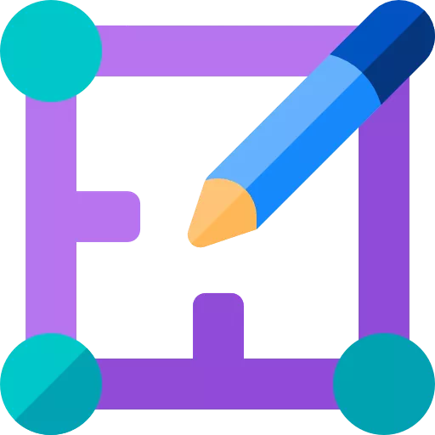

**Initial Planning**

The first order of business is to sit down with the team and create a detailed set of development and technical specifications. These specifications serve as a roadmap for the rest of the web development process.

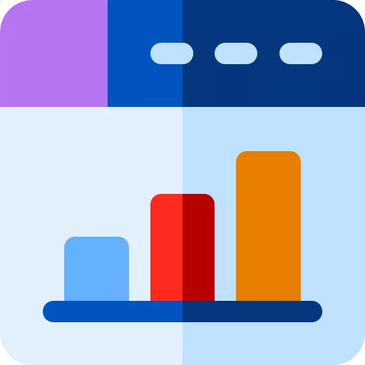

**Wireframing**

Wireframes are the first chance to visualize the web application. While they're not nearly as detailed as the final site will be, they give us a visual representation of the site's overall layout.

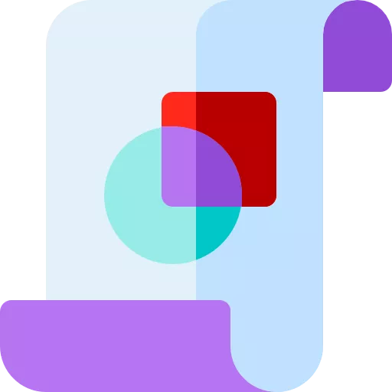

**Mockups**

Once all site mockups are completed and approved, we'll proceed with site mockups. These add color and a bit more detail to the initial wireframes, giving us a stronger visual representation of the final product.

## 

## **Copy & Graphics**

Once we've agreed on a final development based on the mockups, our team will proceed with development, kicking off two phases in unison. The first involves creating site's copy and graphics. Our team will get to work performing SEO and competitive research and come up with the copy and images that will flesh out final site.

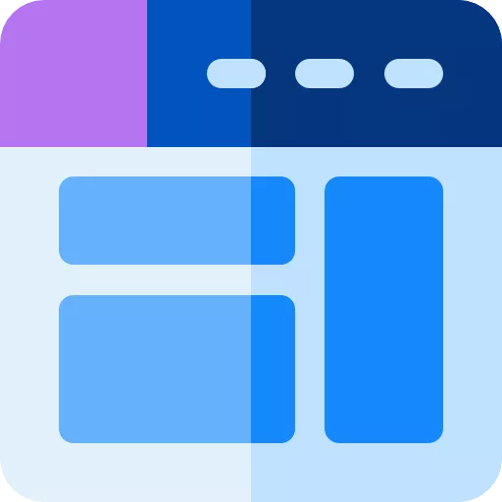

**Development**

At the same time, we'll kick off the technical side of the web development process. This will include deploying CMS, creating custom theme and page designs, and setting up the website's analytics.



## **Testing**

Once our writers, designers, and developers have finished their work, our Quality Assurance team will get to work testing site's performance and reliability. We'll use various tools to benchmark website for loading, responsiveness, and speed, while also ensuring that it works reliably on all web browsers and mobile devices.



## **Deployment & Optimization**

Once we're sure that website is ready to be released to the public, we'll deploy it on our public domain. Then, we'll shift into a monthly support process that will continue for 3 months. During that period, we'll create monthly backups of website, update scripts and plugins to maintain security and reliability, and perform layout and content updates request.

# Project Timeline

The table below represents our projected timeline for the web development project.

|  |  |
| --- | --- |
| Milestone | Time |
| Technical & Development Specification Documents | 2 Days |
| Wireframes | 1 Day |
| Mock-ups | 2 Days |
| Copy & Graphics | 2 Days |
| Development | 1 Month |
| Testing | 1week |
| Public Launch | 1 Day |

**Total estimated Period** 7 weeks

# Pricing

The table below details the costs associated with the web development project.

|  |  |
| --- | --- |
| Milestone | Time |
| Initial invoice | 300,000 Tshs |
| Project invoice 2 | 300,000 Tshs |
| Final invoice | 400,000 Tshs |

**Total Price 1,000,000 Tshs**

# Project Terms

**AdoreTz** will build a website with **Estate Link** according to the description laid out in this proposal. Any additional features, pages, or other changes to project requirements may affect the timeline and costs laid out in the tables above, and will require a separate change order document.

All works produced as a result of the above described web application development project will become the intellectual property of the **Estate Link** also AdoreTz reserves the right to use visual representations of the final product as part of our project portfolio.

## **Acceptance**

**AdoreTz Estate-Link**

**Full Name**

Jackson Karume

……………………………………

**Full Name**

………………………………………

**Date**

**16/02/2021**

………………

**Signature**

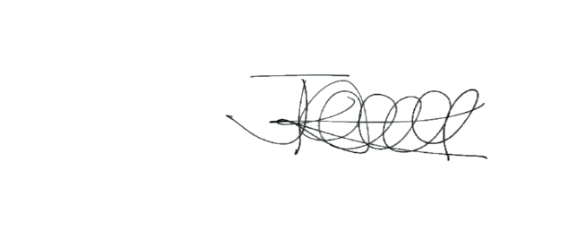

**…….………….**

**Date**

………………

**Signature**

………………